**Chapter-17 Object Oriented Programming**

Object oriented programming is about modeling a system as a collection of objects, where each object represents some particular aspect of the system. Objects contain both functions and data.

**Classes and constructors:**

Classes are a template for creating objects. They encapsulate data with code to work on that data.

Constructor: it is a special function that creates and initializes an object instance of a class. A constructor gets called when an object is created using the new keyword.

**Note:** Classes cannot be hoisted like functions.

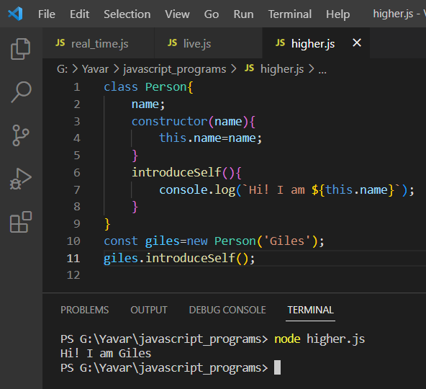

**Omitting constructor:**

If you dont need to do any special initialization, you can omit the constructor and a default constructor will be generated.

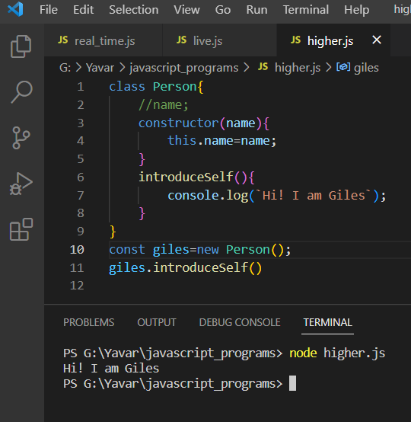

**Inheritance in Javascript:**

Inheritance allows to access the properties and methods from the parent class to child class using the extends keyword.

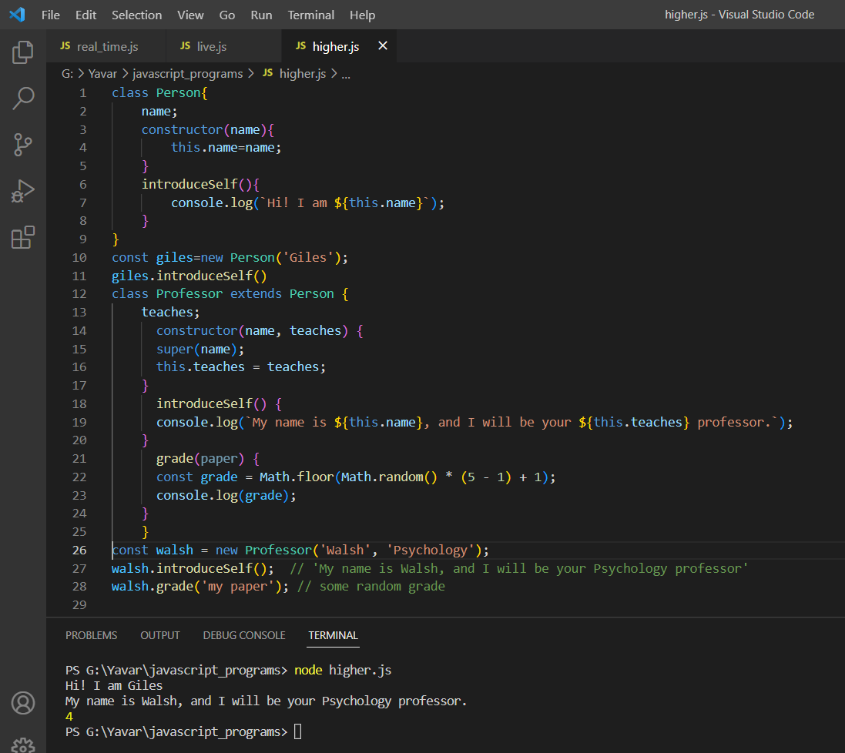

**Encapsulation:**

Maintaining an object’s internal state private and making a clear division between its public interface and its private internal state is called encapsulation.

